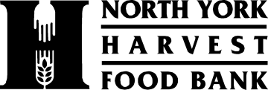

Volunteer Opportunity – Grace JerkFest
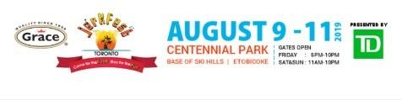

North York Harvest Food Bank
The North York Harvest Food Bank is the primary food bank for northern Toronto, distributing just 2 million pounds of food to 24,000 through 77 neighbourhood programs, from our centrally located distribution centre, to an area bounded by Hwy. 27, Steeles Avenue, Victoria Park, and St. Clair Avenue/Eglinton Avenue.

As an independent, charitable organization, we envision a community where all members are able to meet their food needs. Our efforts are focused in three major areas: developing dignified community food programs, creating public awareness about hunger and its causes, and engaging the community in deciding how best to meet its food needs.

Grace JerkFest – Friday August 9, Saturday August 10 & Sunday August 11
North York Harvest has organized a fundraising event in partnership with Grace JerkFest which will take place at Centennial Park in Etobicoke. To raise funds for our organization, volunteers will be asking JerkFest participants for financial donations.

Duties
- Attending a brief training session at North York Harvest Food Bank
- Asking JerkFest participants for financial donations

Skills/Qualifications
- 15 years of age and over
- Excellent communication and interpersonal skills.
- Fluent in English
- Additional languages an asset

Dates and Times
- Friday August 9, 6pm to 10pm
- Saturday August 10, 12pm to 3pm or 3pm to 6pm
- Sunday August 11, 12pm to 3pm or 3pm to 6pm

If you are interested or wish more information, please contact Lisa Anderson, Manager of Volunteer Services, at lisa@northyorkharvest.com or 416-635-7771 x 29 or Henry Chiu, Director of Development, at henry@northyorkharvest.com or 416-635-7771 x 26

North York Harvest Food Bank 116 Industry St. Toronto ON M6M 4L8 416-635-7771 www.northyorkharvest.com

